Кодграббер

Pandora FANTOM

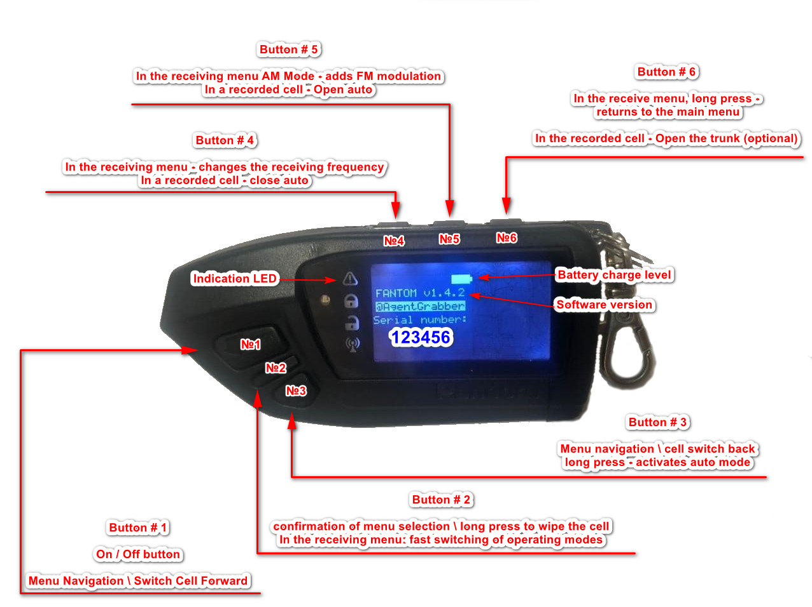

List of supported security systems

Mode 1 – AM-FМ_Factory

(433 MHz - Europe)
- A.P.S. (entire keeloq lineup keeloq)
- Advanced
- Alligator (lcd pagers all keeloq)
- Alligator (all additional keeloq keychains)
- Alligator (pagers with LEDs all keeloq)
- AlligatorS250,S275
- Alligator (with feedback pagers with the new coding of the S-400 2WAY series - S-875 RS 2WAY)
- APS 2700,2800,2900 New line up
9. APS7000-9000
- Berhut (additional key rings)
- Berкut (pagers)
- Black-Bug (greenled)
- Black-Bug super (with red LED)
14. Cenmax (A-700 A-900 )
15. Cenmax (HIT-320 keeloq models)
16. Cenmax (VT-200,VT-210)
- CENMAX VIGILANT ST-5, ST-7, ST-10, V-7, MT-8autorun
- Cenmax-MT7,
- Challenger (with new dynamic code CFM2) autorun.
- Challenger new models with a modified code CFM model ch8000i, x-1.
Chelendger ( whole range of keeloq ch-7000i)
- Cheetah CM-212
- ConvoyXS
- Duplex
- Eaglemaster
- ENFORCER
- EXCALIBUR
- FANTOM F-731,F-635LCD
- Faraon
- Fighter
- Fortress
- Godzila
- Gorgon (withred LED)
- GUARD ( keeloq red LED key rings)
- Harpoon H one,H2
- Inspektor
- Jaguar (whole range of keeloq jx-2000 etc.)
- Jaguar EZ-Betta, EZ-Alpfa,EZ-one
- jaguarseriesja,jb
40. KGB ( FX-3,FX-5,FX-7)
- KGB (additional key rings including old models)
- KGB (pagers with feedback, tested on-VS 4000)
- MagicSystems MS-156MS-225
- MagicSystemsMS-BAIKAL2
- Mangust EMS 1.7, 1.9, 1.7R, 1.9Rautorun.
- Mongouse
- Mystery (LED pager) MX-503,MX-505
- Mystery additional key rings mx-605, mx- 605RS,607,705,905,905RS.
- Pandora (series RX)
- Pantera-(QX)
- Pantera(SX)
- Pantera (with feedback pagers with the new coding of the SLK 350 SC-SLK-675 RS series, inclusive)
- Pantera (with feedback pagers on the 5XXX series inclusive)
- Pantera СLK355
- Partisan
- RedScorpio
- Reef (green LED)
- REEF (withred LED)
- Scher-KhanLogicar(AM)
- Sherif ( entire range of keeloq) autostart.
- Sherif (with the new dynamic code CFM model ZX-1055, ZX-1060) autorun.
- Sherif zx-999 (newlineup)
- Sheriff 1070 CFM2 New key, new encryption. autorun.
- Sheriff 1090 CFM2 New key, new encryption. autorun.
- Sheriff 750 CFM2 New key, new encryption.
- Sheriff 940 CFM2 New key, new encryption.
- Sheriff T80-TORT82-TOR
- Sheriff zx730 (with new dynamic code CFM2) autorun.
- Sheriffzx-930
- Sher-Khan AM А (autorun),В,Vegas.
- StarLine24V
- StarLine-Twage А4,A2 autorun.
- StarLine-Twage А6,А8,А9,autorun.
- StarLine-Twage В6 autorun.
- StarLine-TwageВ9 (optional keychain)
- StarLine-Twage В9(interactive blue pager)
- StarLine-Twage В9(black pager) autorun.
- StarLine-Twage В6 (blue pager ) autorun.
- Starline C6, C9 (additional key rings)
- Tomahawk TZ
- Tomahawk X3 и т.д. серия Хautorun.
- Tomahawk(TW7000,TW9000,TW9010,TW7010,TW7020,TW7030,TW9020,TW9030,950LE) autorun.
- Whister
Abnormal alarms (FM band):
1. Scher-Khan III, IV, 3, 4, 5, 6, 7,8
(feedback is possible, that is, it records the driver’s call, a hit on the wheel, a hit on the glass)
2. Scher-Khan 7H, 8H, 9, 10(PRO1)
3. Scher-Khan 7B, 8B, 9, 10(PRO2)
4. Scher-Khan Magicar 7S, 8S, 11, 12(PRO3)
5. Magicar Seven (M100 AS GOLD IV) (cool). Magicar M902, M903,M909, M939f startup, trunk, mute Magicar korea 904, M101,M110
6. Easycar EW402A, EV402A, E402A
7. Easycar E701A,E702A
8. Easycar E5A,E8A,E7A

Standard alarms system:

Mode 1 – AM+FM Factory

FORD (433 Mhz – Europe) FORD (315 Mhz – USA)
Fiesta (2008 – 2012) Fiesta (2014 – 2017)
FiestaMk 6 (2013 – 2019) F 150, 250, 350, 450 (2011 - 2016)
Explorer (2010-2015) Mustang (2008-2016)
Edge (2010-2014) Taurus/Focus (2008-2016)
Fusion (2002 – 2012) Explorer (2008-2016)
Focus (2004 – 2011) Expedition (2008-2016)
Galaxy (2006 – 2010) MKX (2011-2012)
Kuga I (2008 – 2012) Navigator (2014-2017)
Mondeo Mk IV (2006 – 2010) Edge (2007-2013)
Connect(2013-2018) Escape (2010-2013)
Transit (2006-2014) Flex (2009-2012)
Tourneo Courier (2014 – 2019) Fusion (2006-2012)
B-Max (2012 –2017)
C-Max (2003 –2010) Lincoln MKX (2007-2012)
S-Max (2006 –2010) Lincoln MKZ (2007-2012)
Maverick (2000-2007) Lincoln Zephyr (2006)

Mazda Mazda Tribute (2008-2011)

Mercury Mariner (2005-2011)
Mercury Milan (2006-2011)
Mercury Sable (2008-2009)

HYUNDAY KIA
Solaris (2011 –2014) Rio (2011-2014)
Accent (2011-2014) Sorento (2002-2012)
i30 (2007-2010) Venga (2010-2017)

JAGUAR LANDROVER
X-Type DISKAVERI-2 before 2009
S-Type Freelander before 2010
XJ, XJR, XJ8
(all up 2008)

Subaru (433 Mhz – only europe)
Forester (2007-2017)
Impreza (2000-2016)
Outback (2000-2014)
Tribeca (2004-2014)
Legacy (2003-2014)
XV (2011-2017)

AUDI (433 Mhz – europe)
A2 8Z (2000-2007) S4, 8E2 (2004 –2008)
A3 8L (1997-2003) S4, 8E (2000 – 2004)
A4 8E/8H (2000 – 2008) TT 8N (1998-2006)
A6 4B (1997-2004)
A8 4D (1994-2002)
RS4, 8E (2000 –2008)
S6, RS6 (2002 –2006)

TOYOTA, LEXUS
Lexus Rx xu30 300, 330, 350, 400 (1997-2008) Lexus j100 lx470 (1997-2007)
Lexus LS3 (2000-2006)
Corolla 7(1999-2001)
Land Cruiser j100 (1997-2007)
Land Cruiser Prado j120 (1997-2009)
Harrier (1997-2013)
Solar 1997 — 2008 (except smart)
Camry 1997 — 2008 (except smart)
Toyota Yaris 1997 — 2008 (except smart) Solar 1997 — 2008 (except smart)
(only iron keys)

Mode 2 - FM Factory

New FORD (433 MHz – only Europe)
Ford Focus III (2011 -2018)
Ford Kuga II / Escape (2012 - 2019)
Ford Mondeo (2010- 2014)
Ford C-Max (2010 - 2019)
Ford Galaxy (2010 - 2019)
Ford Grand C-Max (2010 - 2019)
Ford Transit (2014 – 2018)
Ford Transit Custom (2012 – 2017)
Ford Tourneo Connect (2009 –2013)
Ford Tourneo Connect (2013 –2019)
Ford Tourneo Custom (2012 – 2017)
Ford S-Max (2010-2015)
Ford Ranger (2011 - 2015)

JAGUAR (433 MHz – Europe)
XF (2010-2016), XK (2010-2014)
XJ (2009-2016)

HYUNDAY
(433 MHz – Europe; 315 MHz - USA)
Solaris (2014-2020)
Accent (2014-2020)
Santa Fe (2005-2018)
IX35 (2010-2015)
IX20 (2010-2019)
I10 (2008-2019)
I20 (2008-2018)
I30 (2011-2019)
SONATA (2009 – 2017)
ELANTRA (2006-2019)
AVANTE (2010-2019)
I40 (2011-2019)
TUCSON (2009-2015)
VERNA (2010-2017)
VELOSTER (2011-2017)
H1 (2007-2018)
STAREX (2007 – 2017)
GRAND STAREX (2007-2018)
PORTER (2016-2017)
Trajet (2001-2008)

Opel (Vauxhall)
Only regular key
Crossland (2017-2020)
Grandland (2017-2020)

KIA

(433 MHz – Europe; 315 MHz - USA)
Rio (2015-2020)
Rio X-Line (2017-2020)
Sportage before 2008
Sportage (2008-2016)
Mohave (2008-2016)
Sorento II (2009-2020)
Sorento Prime (2014-2017)
Cerato (2003-2019)
Forte (2008-2018)
Ceed (2006-2018)
Soul (2008-2019)
Optima (2010-2015)
Stonic (2017-2020)
Picanto (2011-2017)
Carens (2013–2019)
Rondo (2013-2019)
Magentis (2005 – 2010)

Fiat
Scudo (2007-2020)
Fullback (2016-2020)
Doblo (2010-2015)
Ulysse (2007-2011)
Toyota ProAce (2013-2016)

PEUGEOT (Only mode 1!)
207 (2006-2015)
307 (2005—2008)
307 cc (2003-2011)
407 (2004-2011)
807 (2005-2009)
C-Triomphe (2006—2012)
C-Quatre (2010-2016)
308 (2007-2009)

PEUGEOT (Only mode 2!)
208 (2012—2019)
308 (2007—2013)
308 (2013-2020)
308 sw (2011-2016)
301 (2012-2019)
408 (2012-2020)
508 (2011—2018)
807 (2009-2014)
2008 (2013—2019)
3008 (2009-2016)
4008 (2012-2017)
5008 (2009-2016)
RCZ (2010-2015)
Partner (2008-2018)
Expert (2007-2019)

CITROEN (Only mode 1!)
C2 (2003-2009)
C3 (2002—2009)
C4 (2004-2012)
C4 Picasso (2006-2013)
C3 Pluriel (2003—2010)
C5 (2008-2011)
C8 (2005-2009)
C6 (2005-2012)

CITROEN (Only mode 2!)
C3 Picasso (2009-2017)
C3 (2009-2016)
C3 (2016-2020) - only regular key
C4 (2010—2020)
C4 Cactus (2014—2020)
C4 Aircross (2012—2017)
C4 Picasso (2010-2019)
C4 Grand Picasso (2013-2019)
C5 (2011-2017)
C8 (2009-2014)
C-Elysee (2012-2019)
DS3 (2010—2016)
DS4 (2010—2016)
DS5 (2012—2015)
Jumpy, Dispatch (2007-2016)
Berlingo (2008-2019)

Nissan (smart keys)

(433 MHz – Europe; 315 MHz –USA, Japan)
Murano (Z51/Z51R) (2007 – 2015)
Teana (J32/J32R) (2008 – 2013)
Altima (2007-2012)
Maxima (2008-2014)
Versa (2007-2012)
GT-R (R35) (2008-2018)
370Z (2008-2019)
350Z (2005-2009)
Note (E12E) (2013 – 2016)
Rogue (2007-2018)
Skyline (2006-2014)
Pulsar (2013-2018)

Infiniti (smart keys)
(433 MHz – Europe; 315 MHz –USA, Japan)
QX70 (2013-2017)
QX50 (2013-2017)
QX80/QX56 (2010-2017)
Q40 (2014-2015)
Q60 (2013-2016)
Q70 (2013-2017)
FX35 (2008-2013)
FX37 (2008-2013)
FX50 (2008-2013)

Leaf (ZE0) (2010 – 2017)
NV 200 (M20M) (2014 + test)
Tiida (C13R) (2015 + test)
Sentra (B17R/B17RR) (2014 + test)
X-Trail (2013-2018)
Qashqai (2013-2018)
Juke (F15/F15E) (2010 – 2017)
Armada (2016-2019)
Micra (K13K) (2010 – 2013)
Cube (Z12) (2009 – 2019)
Patrol (Y62) (2011 + test)
Pathfinder (2004-2014)

EX (2007-2013)
EX35 (2007-2013)
EX37 (2007-2013)
G25 (2006-2013)
G35 (2006-2013)
G37 (2006-2013)
M35 (2010-2013)
M37 (2010-2013)
M56 (2010-2013)

Mitsubishi
(433 MHz – Europe; 315 MHz -USA)
Pajero (2006-2020)
Pajero Sport (2008-2020)
L200 (2007-2020)
Galant (2008-2012)
Grandis (2008-2012)

HONDA

(433 MHz – Europe; 315 MHz - USA)
Accord (2003-2007)
Stream (2003-2006)
Jazz (2001-2008)
Legend (2004-2008)
Cr-v (2002-2006)
Fr-v (2004-2008)
Hr-v (2001-2006)

MAZDA

(433 Mhz – only Europe)
3,…6, CX7, RX-8 (key Siemens, Visteon, Mitsubishi) 2010-2012

Mode 3 - VAG Group
(434 MHz – Europe; 315 MHz - USA)

Volkswagen
Polo (2009 - 2019)
Jetta (2010 -2015)
Jetta (2014 -2018)
Amarok (2010-2019)
Caravelle T5, Т6 (2009-2019) Multivan T5, Т6 (2009-2019)
Transporter T5, Т6 (2009 - 2019) California T5, Т6 (2003-2019) Caddy (2010 - 2019)
Sharan (2010 - 2019)
Touran (2010 - 2015)
up!/e-up! AA (2011 – 2019)
Beetle (2011 - 2019)
Scirocco (2008 - 2019)
Tiguan (2008 - 2016)
Golf (2009-2012)
Golf Plus (2008-2014)
Golf R (2009-2013)
Passat B6 (2005-2010)
Passat B7(2011-2015)
Passat CC (2012-2016)
Eos 1F (2010 - 2015)
Passat 3AA (2011-2015)
Passat SE (USA, 315 Mhz) (2017 – 2019)
(All up 2008)
Bora, Beatle, Caddy, Golf 4, Golf 5,Golf 5+, Jetta, Passat B5+, В6+, B7+, CC+,
Polo, Touran, Tiguan, Transporter, Multivan, Caravelle, Lupo, LT, Eos, Scirocco

Audi (434 MHz – Europe; 315 MHz - USA)
R8 (2006-2015)
Q3 8U (2011 – 2018)
S1 8X (2014 - 2019)
A1 8ХА/8Х1 (2010 – 2018)
A3 8L,8P (2004 – 2013)
S3 8P (2008 – 2013) Audi RS3 8P (2011-2012) Audi TT 8J (2006 –2014)

Seat

(434 MHz – Europe; 315 MHz - USA)
Seat Alhambra (2010-2019)
Seat Mii AA (2011-2019)
Seat Ibiza 6J (2008-2017) Seat Altea 5P (2009-2015) Seat Leon 1P (06.2009-2012)
Seat Toledo 5P (06.2009-2011) Seat Exeo (2008-2013)
Seat Cordoba (2002-2009)

(all up 2008): Altea, Leon , Toledo , Ibiza , Arosa

Skoda
(434 MHz – Europe; 315 MHz - USA)
Superb 3T (2008-2015)
Yeti 5L (2009-2013)
Skoda Yeti 3T (2013-2018) Skoda Rapid 3T (2013-2017) Citigo (2011-2019)
Octavia 1Z (2008-2013) Skoda Fabia 3T (2010-2014)
Skoda Roomster 3T (2010-2015)
(all up 2008): Fabia, SuperB, Octavia, Roomster

Mode 4 - FM VAZ (433 MHz)
Lada Kalina Lada Priora Lada Granta Niva Chevrolet
UAZ Patriot before 2017
Datsun

Mode 5 - FM Sherkhan (433 MHz)
Scher-Khan III, IV
Scher-Khan 3, 4, 5, 6, 7, 8
Scher-Khan 7H, 8H, 9, 10 (PRO1)
Scher-Khan 7B, 8B, 9, 10 (PRO2)

Scher-Khan Magicar 7S, 8S, 11, 12 (PRO3)
Magicar Seven (M100 AS GOLD IV) (cool).
Magicar M902, M903, M909, M939f startup, trunk, mute 6.
Magicar korea 904, M101, M110
Easycar EW402A, EV402A, E402A
Easycar E701A,E702A
Easycar E5A,E8A,E7A

Mode 6 – Barrier
Allmatic, AN-Motors, Beninca, Came atomo, Came tam, Came top, Dea,
Ditec gol4c, Doorhan, Faac (433 MHz), GiBiDi, GSN, M code, Nice flo, Nice flor s, Nice smilo, Nero Radio (433 MHz), Marantec, Hormann

Mode 7 – Jamming

Jamming mode. When this mode is selected, jamming at frequency 433 is turned on automatically. You can switch the jamming frequency with button 4, put the jammer on pause with button 1, exit this mode back to the menu - button 6.

Mode 8 – About
Device Information and Serial Number. May be needed when updating firmware via USB.

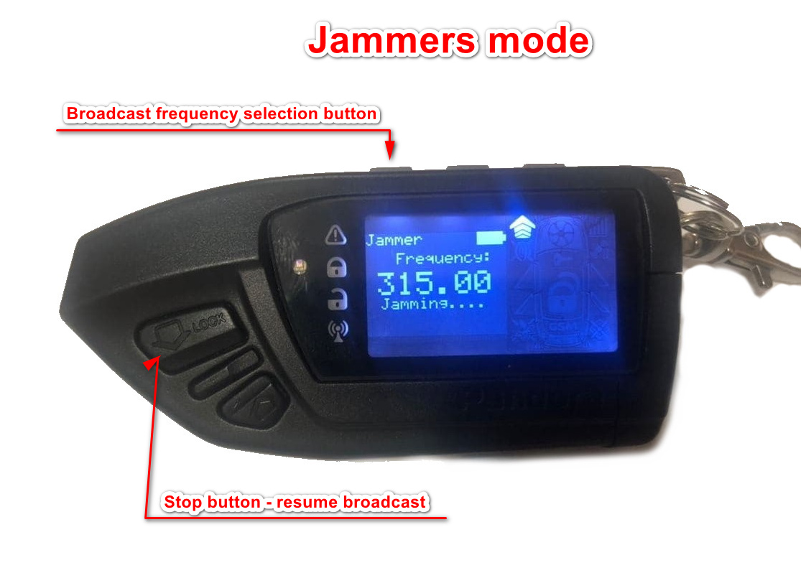

Mode 9 – Change PIN Code

Mode 10 – Language

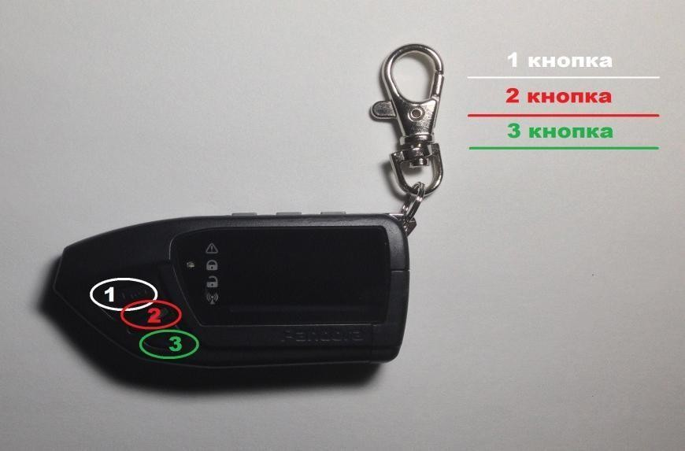
Instructional manual

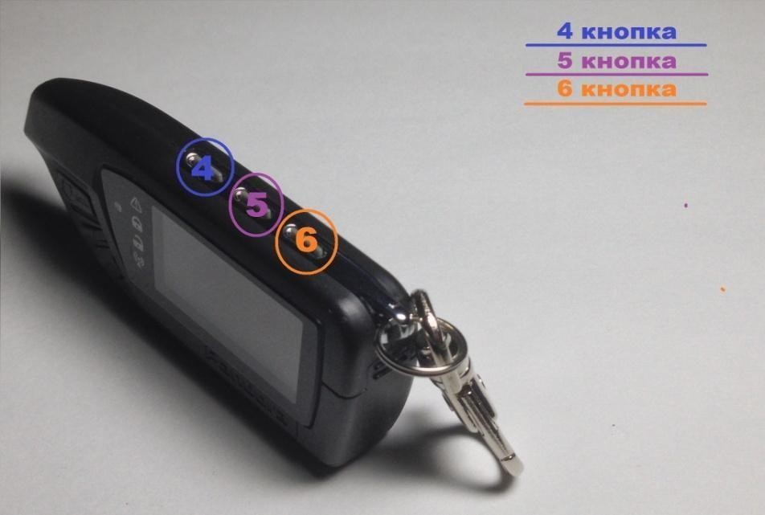

Work in modes 1-8 looks like this.

Switching memory cells forward / backward - buttons 1 and 3, respectively. Erasing the code from the selected cell - holding button 2. If the cell is empty, reception is automatically turned on. When a signal is received, the device vibrates twice and displays the type of received alarm on the display. If the received signal is already in the memory, the device vibrates briefly and shows the number of the cell in which this signal is recorded in the right edge of the display.

If the cell is empty, you can switch the frequency of reception with button 4, enable or disable the simultaneous reception of AM and FM with button 5 (only in the first mode), enable or disable auto mode (hold button 3).

If a signal is recorded in the cell, the buttons are opened and controlled by buttons 4,5,6. Shortly 4 - close, long 4 - the accepted command, short 5 - open, long 5 - trunk / additional functions (not on all systems), short 6 - autostart / trunk (not on all systems).

Long 6 - exit back to the menu

Briefly 2 - quick switching between modes 1, 2 and 3 (AM + FM + Staff, FM staff and VAG)

Enabling or disabling feedback jamming - simultaneously holding buttons 4 and 5, while the Jamm indicator lights up on the display. Catch code

- simultaneous pressing 4 + 6, the display will catch up with the catch-up code, after which the next sent command will be increased by 50 counter clicks.

Useful when opening occurs a long time after recording.

In sleep mode, shows the clock and date. Record in 0 cell of your signaling or gate and in the off state the ability to use without causing suspicion.

4-digit pin code with input on the display (i.e. you see what you enter)

Instructions for barriers Came and Nice.

Enumeration mode for Came and Nice barriers.

In order to select the code for the Came or Nice barrier (not all models, only those controlled by Came Top, Nice Flo remotes), you need to select the appropriate mode. After entering the start search mode for Came - button 4, for Nice - button5. The selected cell must be empty.

After you started the search, you need to stand at the barrier and wait until it opens. As soon as it opens, you should immediately press and hold button 2, the search will stop. Next, you need to wait until the barrier itself closes, then press and hold button 1 (rewind), hold it until the barrier opens again, then immediately release the button. Next you cancheck the selected code by pressing and holding button 5, the barrier should open. Saving the selected code - pressing the button 4.

For Nice barriers, busting looks exactly the same, only it lasts longer (Came
- about 10 minutes, Nice - about 20 minutes). It is started by pressing button 5 immediately after entering enumeration mode, on an empty memory cell

For all questions of support, updates, service, please contact AgentGrabber.com

Contact us:
Our website: https://agentgrabber.com
Email: agentgrabber@gmail.com

WhatsApp: +380634183434

Telegram: +380634183434

or https://t.me/AgentGrabber

